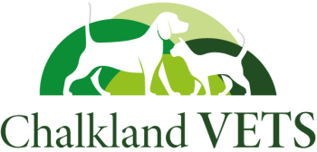
Refer & Reward Scheme!
CV01
Voucher No:




Invite a friend and you’ll both receive a £15 credit!

For further assistance, contact us at enquiries@chalklandvets.co.uk or on 01249588805
Please tick which branch you collected this voucher from:
Chippenham
Calne
Corsham
Melksham
Name:
Address:
Postcode:
Phone No:
Pets Name:

Just fill in your details below and give this voucher to a friend.

When they bring it to their pet’s first appointment, you’ll each get a £15 credit added to your account.

How It Works:
Invite a friend or family member to our practice and you’ll both receive a £15 credit as a thank you.

